Name: Given

2023

Surname: Mogowe

Module code: XITM5229

Date: 17/11/2023

Student number: ST10070150

Scenario: Hospital Network Design

Lecturer’s name: Mr Rathete

Programme name: Work Integrated Learning 2

Diploma in Information Technology Management

Table of Contents

Introduction 3

Skills Learned 4

Soft Skills 4

Hard Skills. 4

Role in the team 5

Were you the leader or did you follow? 5

Did you do as much or more than others? 5

How did you feel about being in the group? 5

What did you do when there was conflict in the group? 5

Is there anything you have learned about being a member of a group? 5

Time management and planning 6

Did you finish the task on time? 6

Was it rushed at the end? 6

How did you plan your time? 6

Did this work or is there something different you should or could have done? 6

Could this have been done differently or better? 6

What was good about the way you managed your time and planning? 6

Technology, presentation, and information 7

Where did you find the information, you needed to do this work? 7

What technology did you use? 7

How well? 7

What else could you have used? 7

What would you do differently/the same if you needed to do this again as far as the use of technology and presentations goes? 7

Strengths and areas to do better (weaknesses) 8

What did you do well? 8

How do you know you did this well? 8

What did you not do that well? 8

What would you do differently next time and why? 8

Mentor or supervisor 9

What part of this relationship worked well for you and what did not? 9

How could you have made the relationship better or stronger? 9

Impact 10

How do you think others (the organisation, others in your group, the simulated workplace) benefitted from the work you did? 10

Could you have had a greater impact? How? 10

Conclusion 11

# Introduction

The purpose of WIL Module it allows us to gain technical skills learning how to draw up network diagrams, floor plans and network simulations. It trains us to be steady for workplace environment. It also helps us to work as a team and share ideas on how to deal with a project.

# Skills Learned

## Soft Skills

Effective Communication with my team members.

## Hard Skills.

Technical Skills using MS VISIO and GNS3 (Graphic Network Simulator).

# Role in the team

Describe your role in the team.

## Were you the leader or did you follow?

I was appointed as a secretary.

## Did you do as much or more than others?

We divided the work amongst ourselves, so we worked equally.

## How did you feel about being in the group?

Being in this group taught me that group work and brainstorming ideas will help us for the better future if we keep on working like this. I enjoy being in this group because we all listen to each other with respect no matter you are a leader or secretary.

## What did you do when there was conflict in the group?

I learned that we must stick with each other no matter if one peer struggles don’t chase them out of the group instead, we should help each other.

## Is there anything you have learned about being a member of a group?

Yes, it helped me to be able to work under pressure because I was in charge of all the project diagrams which is not an easy task, but I managed to do everything, and it helped me to be on right track is more like I was training myself to draw network diagrams and configure the IP Addresses of all the PC’s.

# Time management and planning

## Did you finish the task on time?

A confident, yes.

## Was it rushed at the end?

No, I never rushed because I always started my tasks earlier.

## How did you plan your time?

I always made sure that I started my tasks earlier sometimes I would work at midnight to manage time so that I won’t panic on the last day of submission.

## Did this work or is there something different you should or could have done?

Yes, it worked for me.

## Could this have been done differently or better?

Could have done better if time was on our side.

## What was good about the way you managed your time and planning?

What’s good about that is that I was able to respect time by starting and completing my tasks earlier.

# Technology, presentation, and information

Answer the following:

## Where did you find the information, you needed to do this work?

Internet.

## What technology did you use?

Laptop.

## How well?

I did my research using internet on my PC it helped me to complete my tasks.

## What else could you have used?

I also used my cell phone to find information on the social media platforms like LinkedIn, and Facebook.

## What would you do differently/the same if you needed to do this again as far as the use of technology and presentations goes?

Earlier Preparation will help me to gather information and put it into action and that will make my work easier next time I am needed to this again.

# Strengths and areas to do better (weaknesses)

## What did you do well?

Network Diagram.

## How do you know you did this well?

Our inspector rated my network diagram that I did it well.

## What did you not do that well?

Documents was not in the paragraph form and too much point form ruined the quality of the documents.

## What would you do differently next time and why?

Next time I will make sure that I put my documents in a paragraph form and remove point forms, mainly because I want my documents to be quality and professional.

# Mentor or supervisor

Describe your relationship with the WIL coordinator or the mentor in the workplace.

## What part of this relationship worked well for you and what did not?

Communication worked well for me.

## How could you have made the relationship better or stronger?

Effective communication was well constructed.

# Impact

## How do you think others (the organisation, others in your group, the simulated workplace) benefitted from the work you did?

It enhanced their soft skills in many ways, working to learn is like learning to work. Work-integrated learning will teach students how to apply their knowledge in real life providing them with various soft skills and transferable skills that will aid them in future endeavours.

Soft skills refer to character traits that a person develops, which aid them in their professional relationships with colleagues, managers, clients, and more (Scielo, 2022).

## Could you have had a greater impact? How?

Yes, I think this module must be introduced on every qualification because it will train people to be ready for workplace environment (Scielo, 2022).

# Conclusion

The analysis of the hospital network architecture concludes by highlighting both its advantages and disadvantages. Critical medical information is consistently available thanks to a resilient system that is bolstered by a strong infrastructure and redundancy mechanisms. Nonetheless, the network’s flexibility might be improved by considering future scalability and developing technologies.

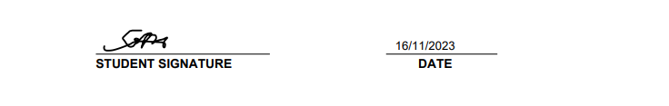Annexure screenshots

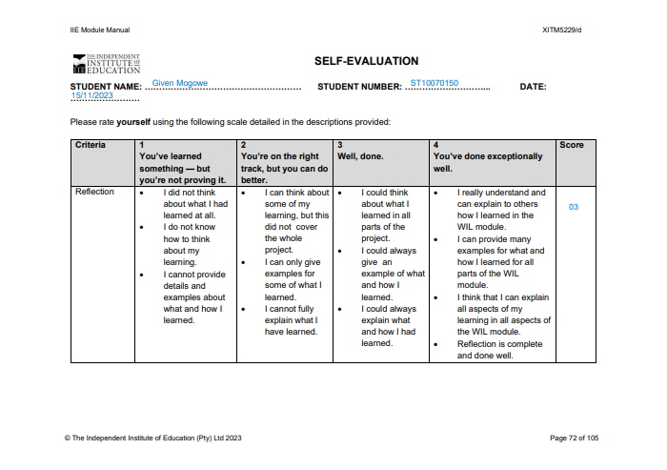

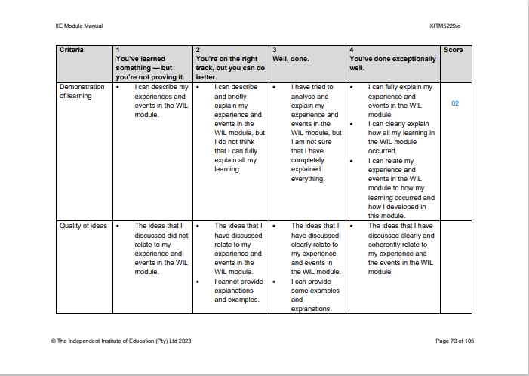

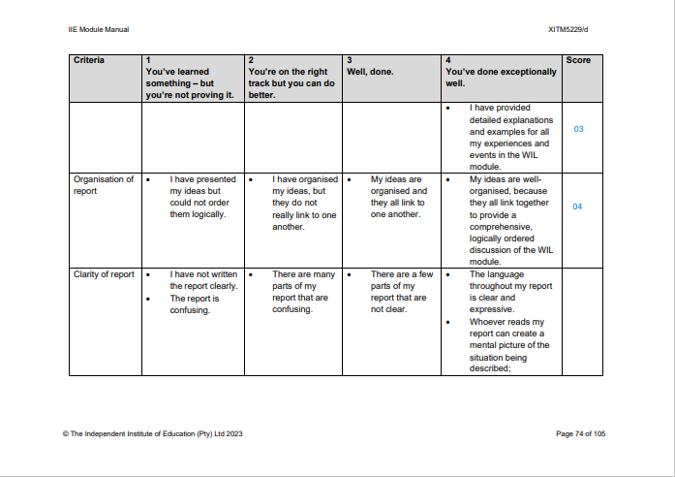

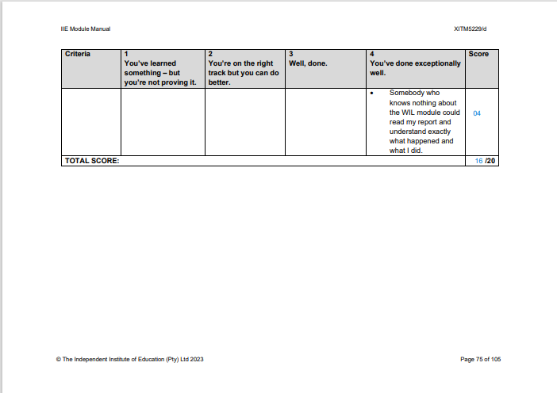

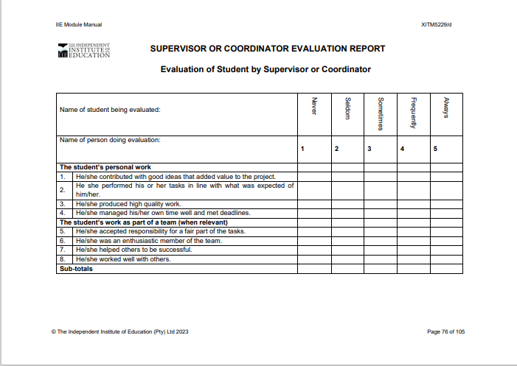

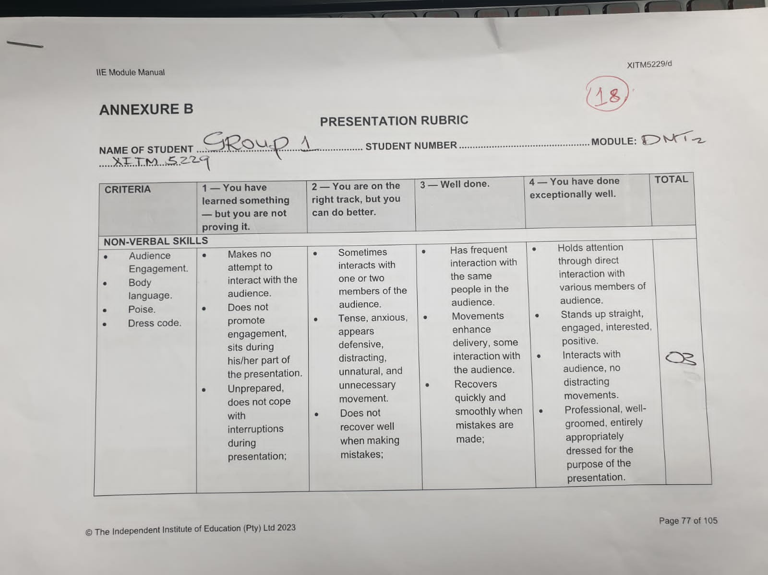

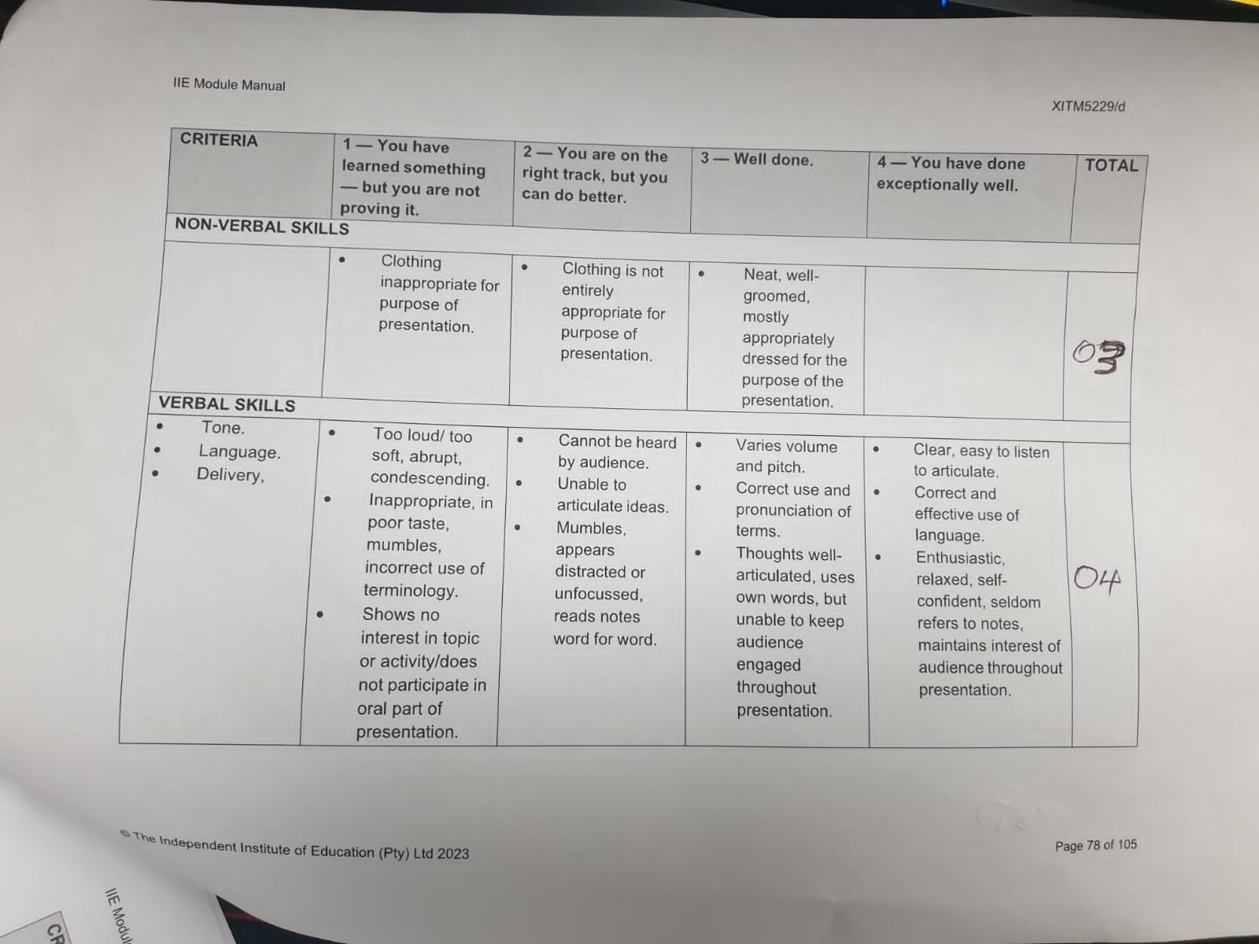

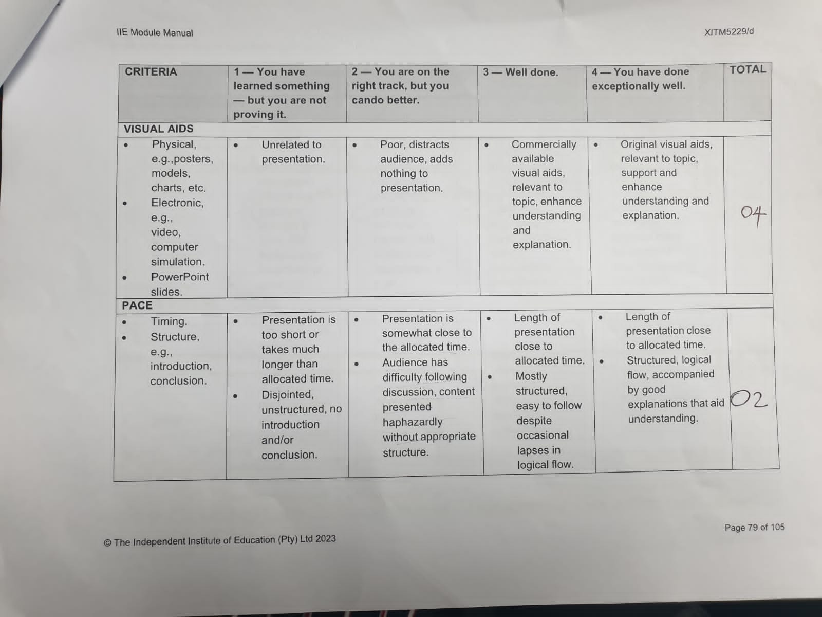

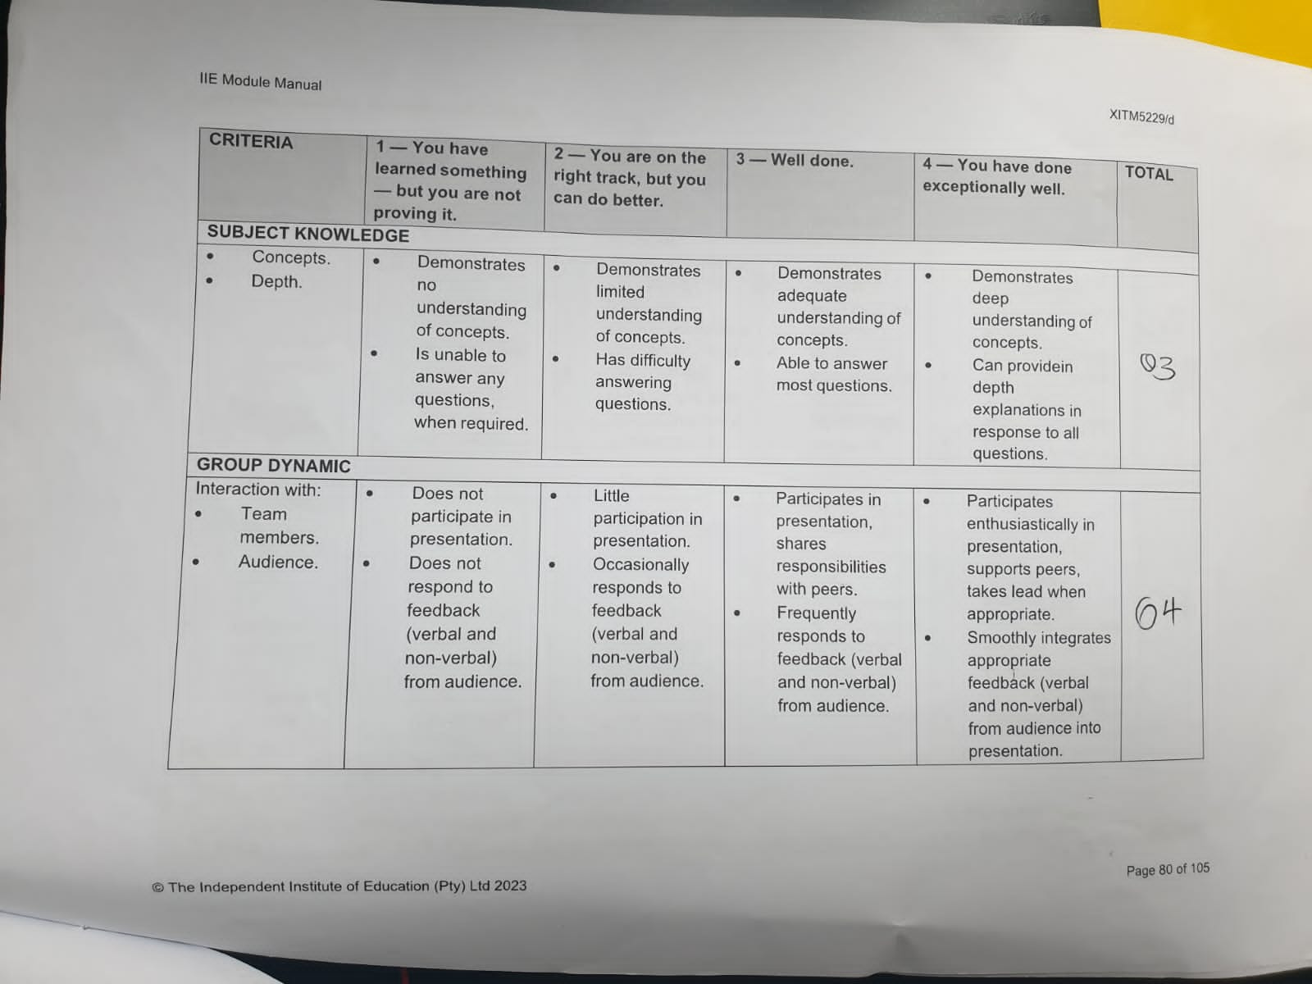

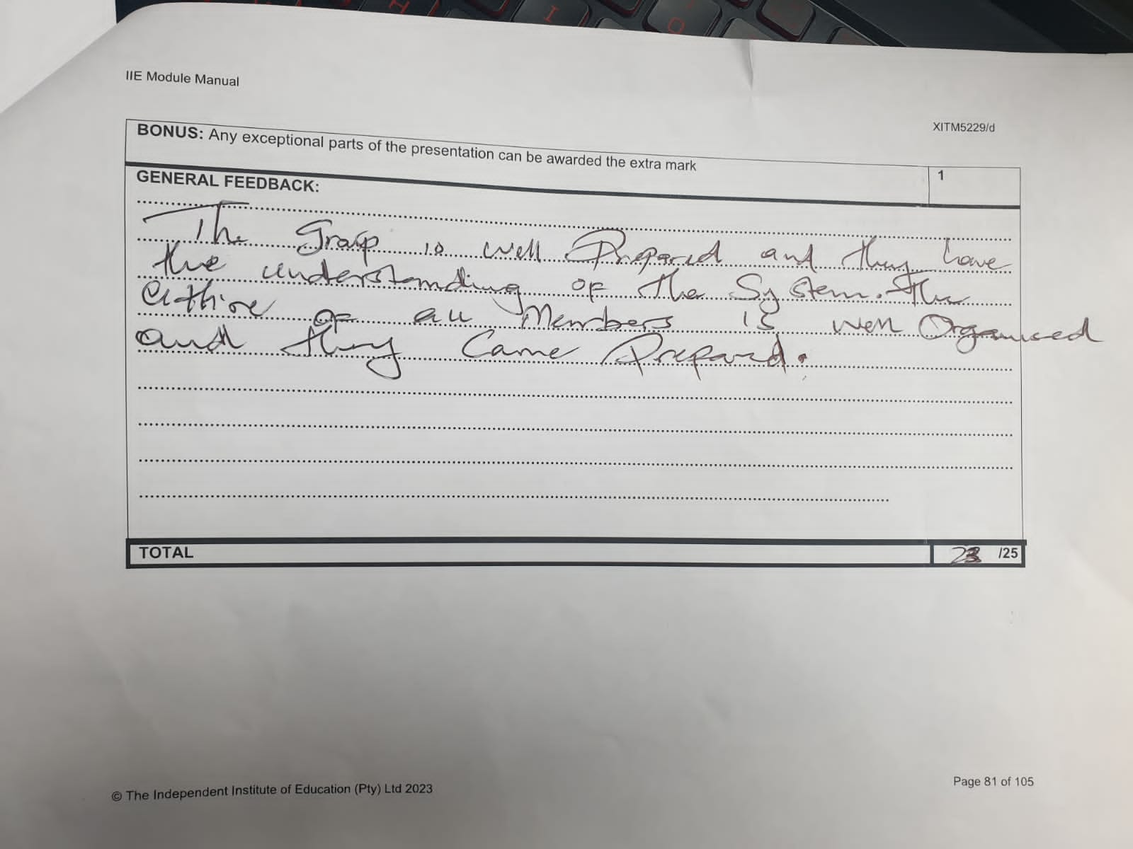

Self-Evaluation









Peer Evaluations for my team members

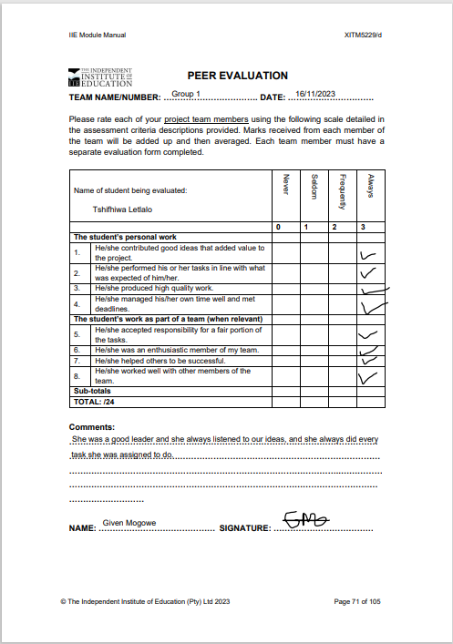

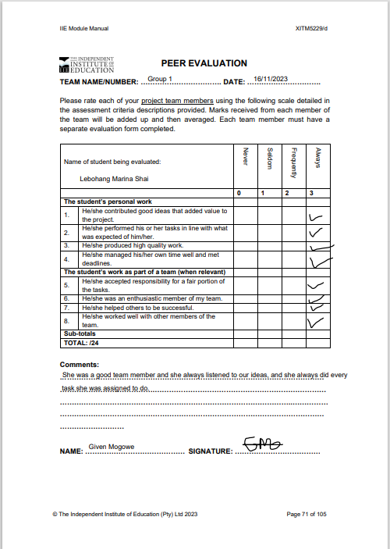

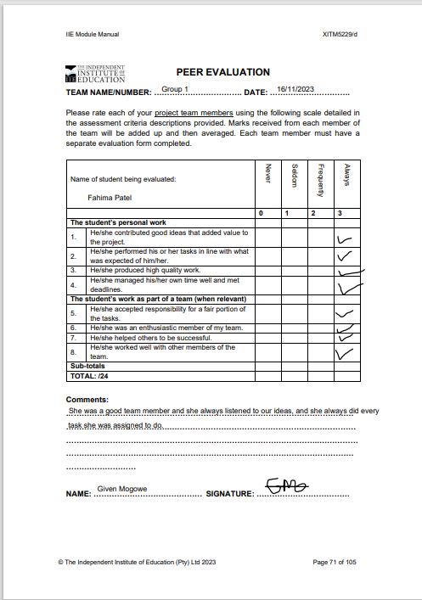

Rubrics annexures















CV



Standard Operating Procedure



# References

Scielo, 2022. *Work Integrated Learning Model.* [Online]   
Available at: <http://www.scielo.org.za/scielo.php?script=sci_arttext&pid=S2519-56702022000100003>  
[Accessed 17 November 2023].